NAME: SAGARSUMAN P MANJHI SUBJECT: PYTHON PROGRAMMING LAB | PRACTICAL: 01 | BATCH : 04  SYBVOC :SEM-III (DS)
Experiment based on input and output variables and operator in python

AIM : Accept marks of 3 subjects and calculate the average , total and percentage
LEARNING OBJECTIVE :
  - To understand the use of input and output statements in Python.
  - To learn how to declare and use variables in Python.
  - To understand different data types used in Python.
  - To learn the use of arithmetic operators in Python.
  - To accept user input and perform calculations.
  - To display the calculated total, average, and percentage.
TOOLS :

Sr. No. | Name Of Resources | Specification | Quantity | Remarks
1. | Hardware | Computer (i5-i7) Ram (Min 16GB) | 1 | For All Practical
2. | Software | Python / IDLE / VS Code | 1 | For All Practical
THEORY :
Python is a high-level programming language used to develop programs and solve problems.
- Input: The input() function is used to accept data from the user.
Syntax: variable = input("Enter value: ")
- Output: The print() function is used to display results.
Syntax: print("Result:", variable)
- Variables: Variables are used to store values in a program.
- Data Types: Python supports data types such as int, float, str, and bool.
- Operators: Operators are used to perform operations on values. Arithmetic operators such as +, -, *, and / are used in this experiment to calculate total, average, and percentage.
Source Code:
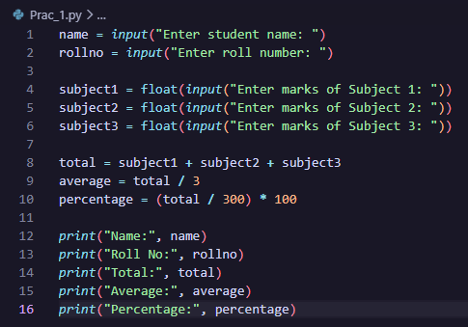
Output:
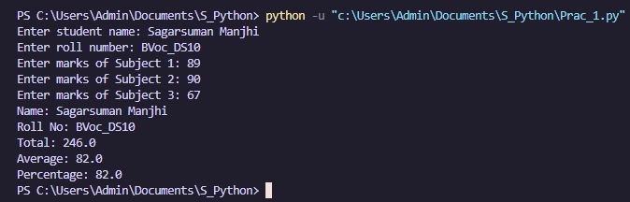
Result and Discussion:
The program successfully accepts the student name, roll number, and marks of three subjects and calculates the total, average, and percentage.
For the given input, Total = 246, Average = 82, Percentage = 82%.
Learning Outcomes:
- Students the use of input() and print().
- Understand variables and data types.
- Learn to use arithmetic operators.
- Learn to perform basic calculations in Python.
Course Outcomes:
- to Understand basic input and output in Python.
- Use variables and data types.
- Apply arithmetic operators.
- Develop simple Python programs.
CONCLUSION :
- A The program successfully accepts student details and marks.
- It calculates the total, average, and percentage.
- The experiment demonstrates the use of input, output, variables, and operators in Python.
VIVA QUESTIONS :
1. What is Python?
Python is a high-level, interpreted programming language used to develop programs and solve problems.

2. Which function is used to accept input from the user?
The input() function is used to accept data from the user.

3. Which function is used to display output?
The print() function is used to display output on the screen.

4. What is a variable?
A variable is used to store a value in a Python program.

5. Which data type is used for decimal values?
The float data type is used to store decimal values.

FOR FACULTY USE ONLY :
Correction Parameters | Formative Assessment [40%] | Timely completion of practical [40%] | Attendance/ Learning Attitude [20%]
Marks Obtained

